1. Topic 1: JVM Concepts and Language Basics( 5 Questions)

* Assignment 1: Write a java program to display “Welcome to Java Programming” and then print your name on a separate line

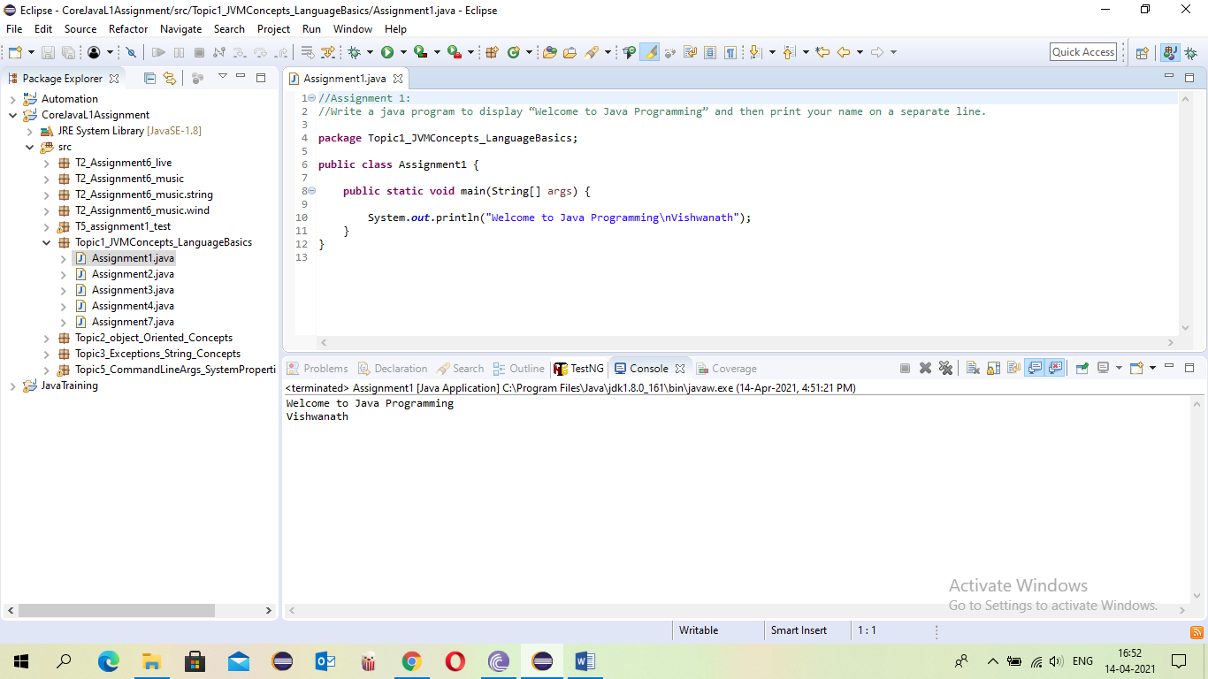

* Assignment 2: Write a Java program to print the result of the following operations. Declare variables and initialize them with given values a. -5 + 8 \* 6 b. (55+9) % 9 c. 20 + -3\*5 / 8 d. 5 + 15 / 3 \* 2 - 8 % 3

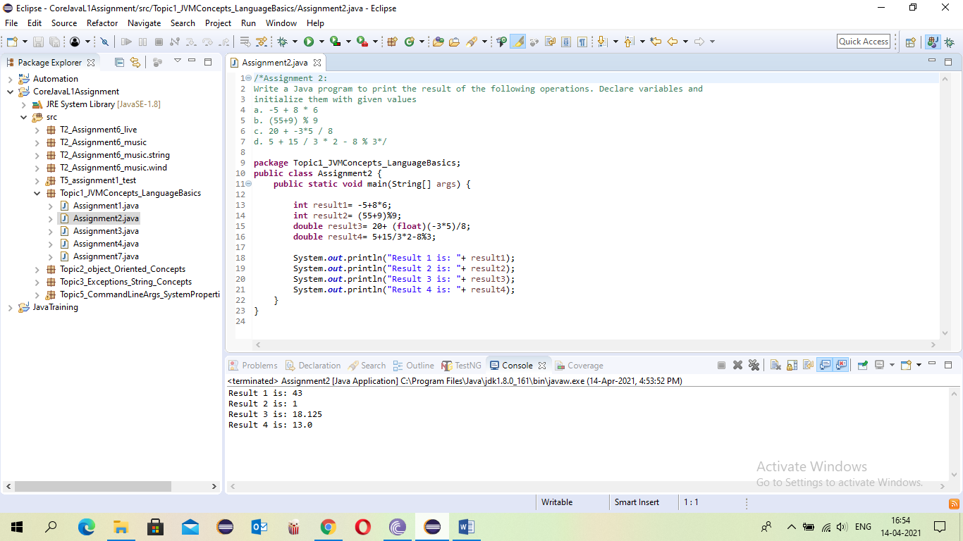

* Assignment 3: Write a Java program to convert minutes into a number of years and days.

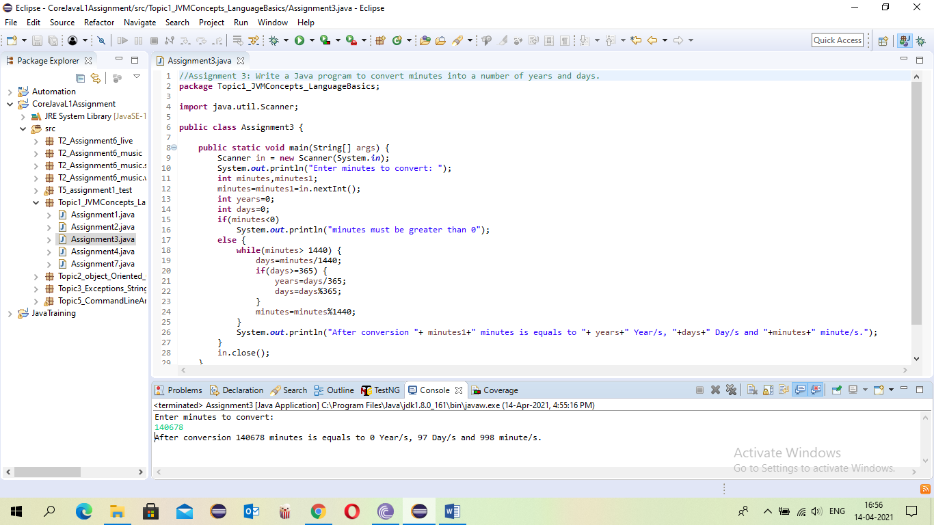

* Assignment 4: Write a program to print month in words, based on input month in numbers.(using switch case)

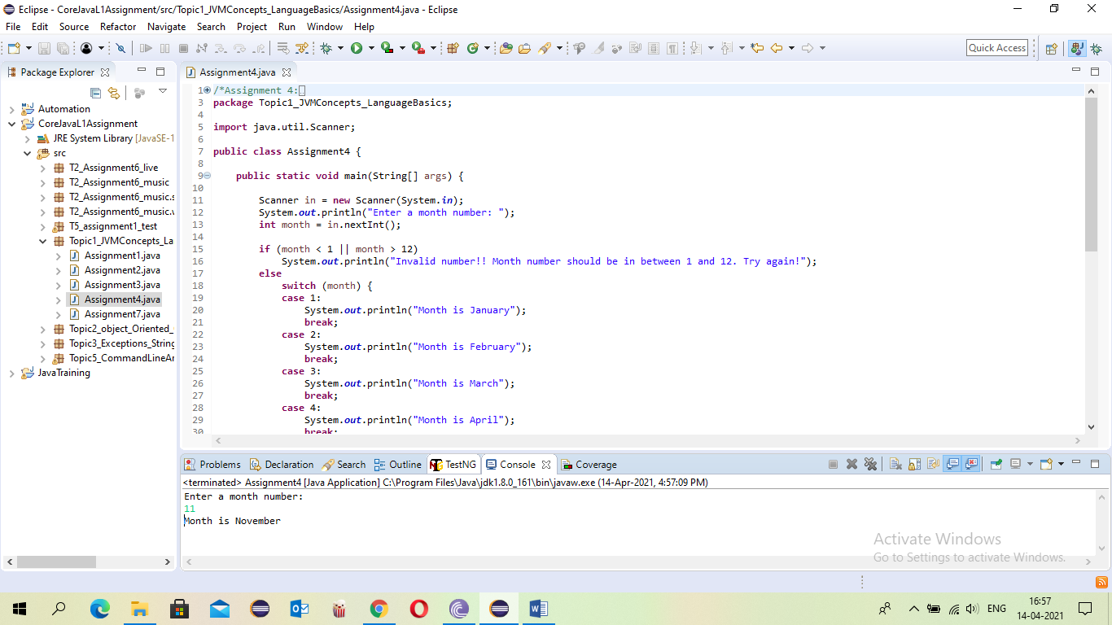

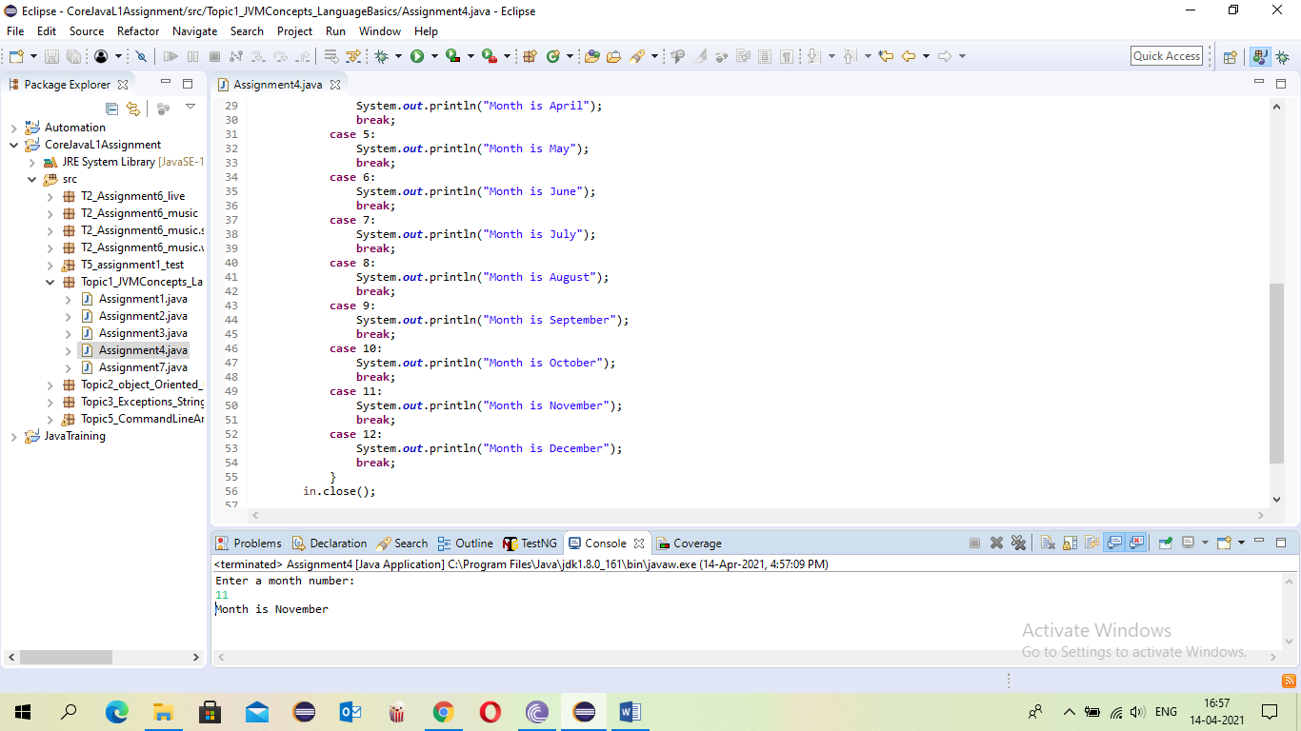

* Assignment 7: Write a Java program to calculate the factorial of a number without using any loop

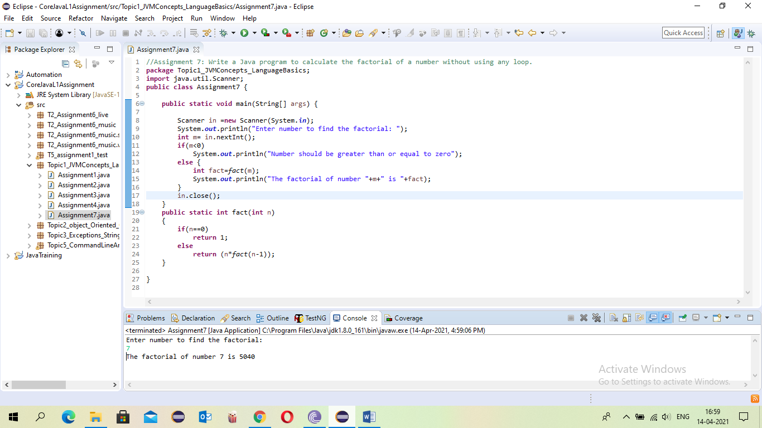

1. Topic 2: Object Oriented Concepts(4 Questions)

* Assignment 1: Write a program to create a class Book with the following - attributes: -isbn, title, author, price - methods : i. Initialize the data members through parameterized constructor ii. displaydeta ils() to display the details of the book iii. discountedprice() : pass the discount percent, calculate the discount on price and find the amount to be paid after discount - task : Create an object book, initialize the book and display the details along with the discounted price

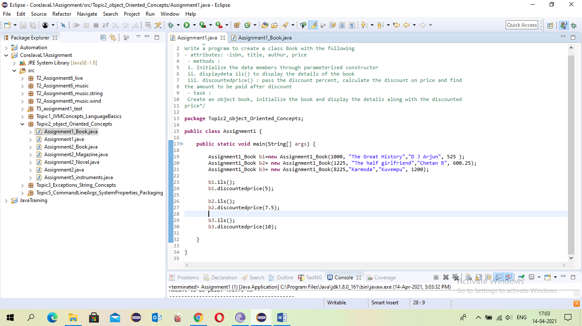

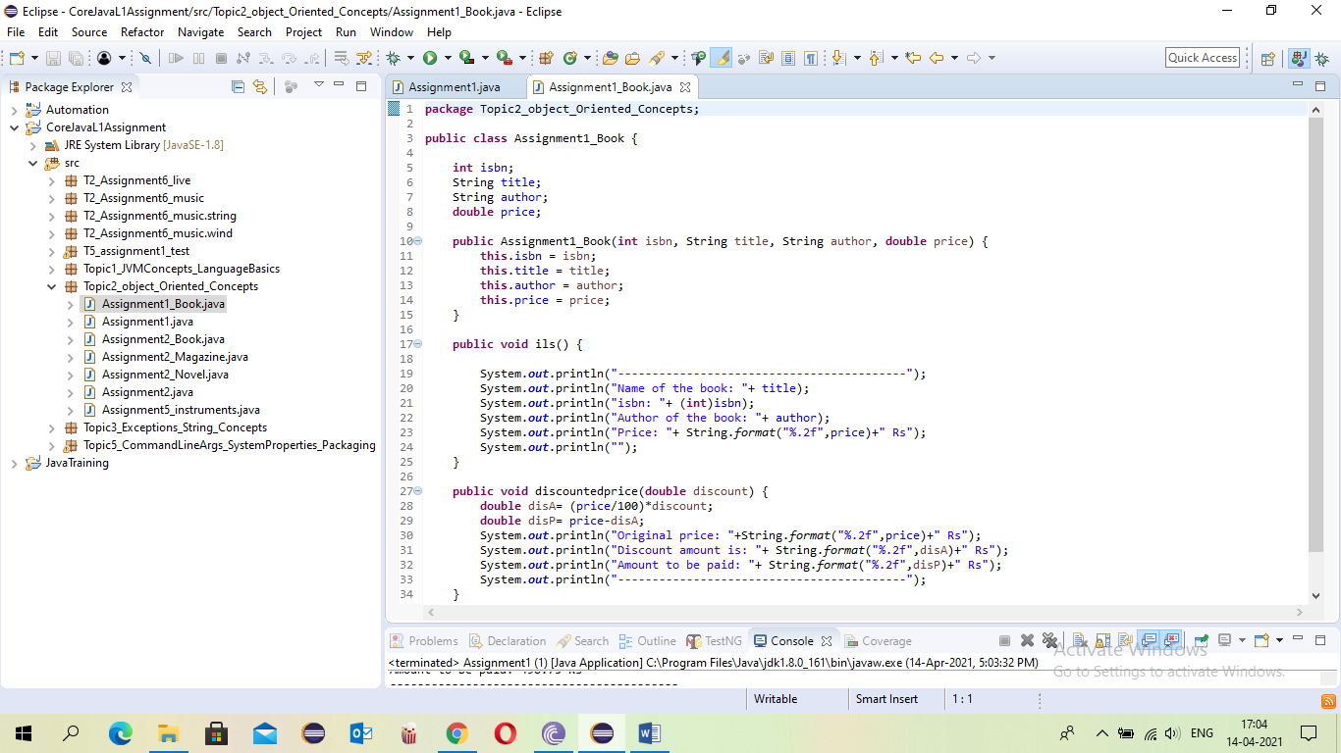

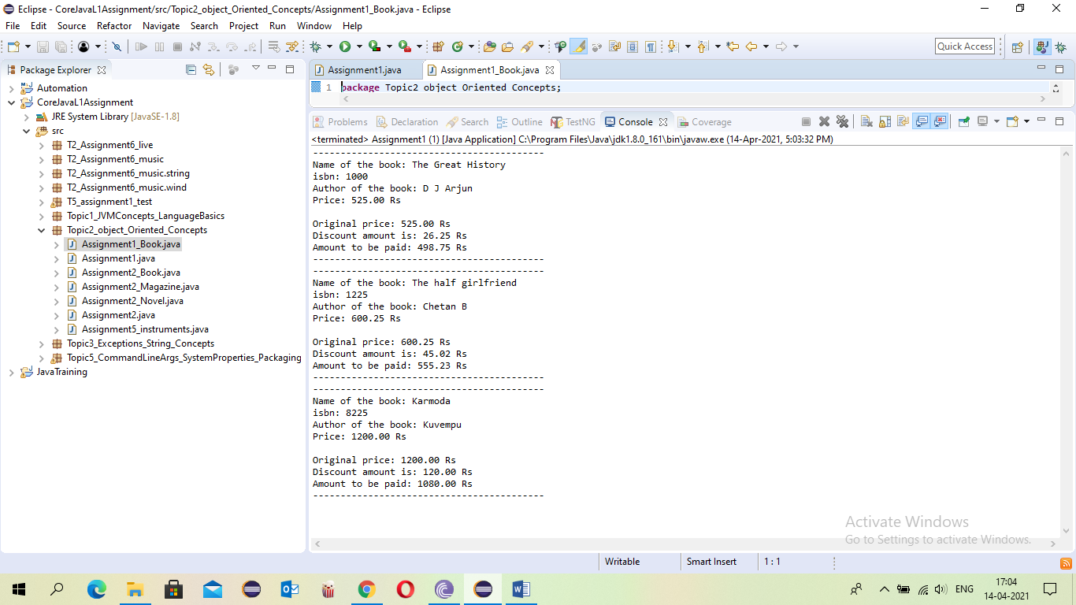

* Assignment 3: Write a program to create a class Book with the following data members: isbn, title and price. Inherit the class Book to two derived classes : Magazine and Novel with the following data members: Magazine: type Novel : author Populate the details using constructors. Create a magazine and Novel and display the details.

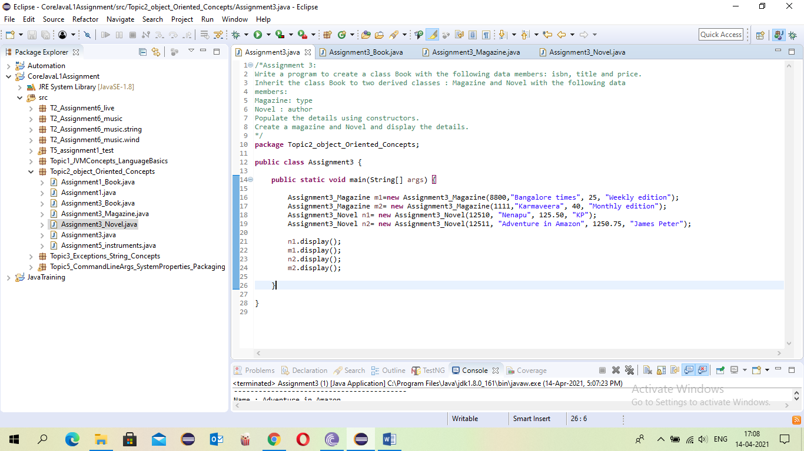

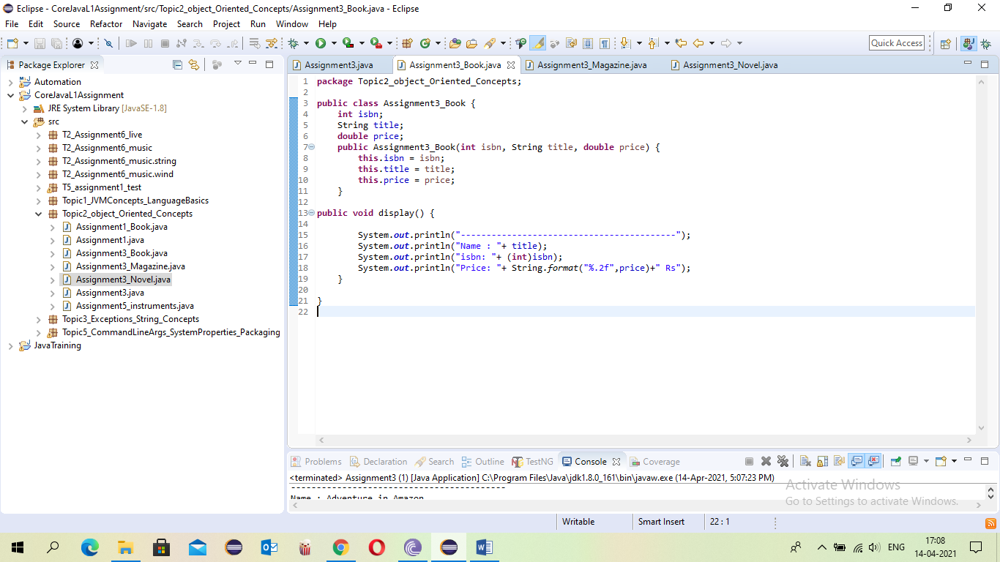

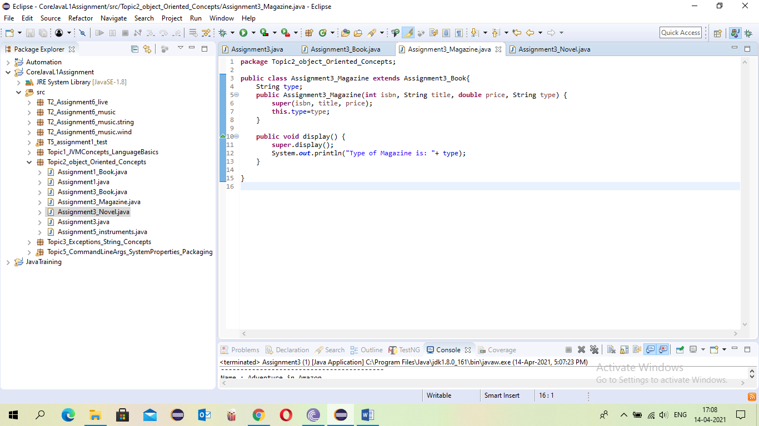

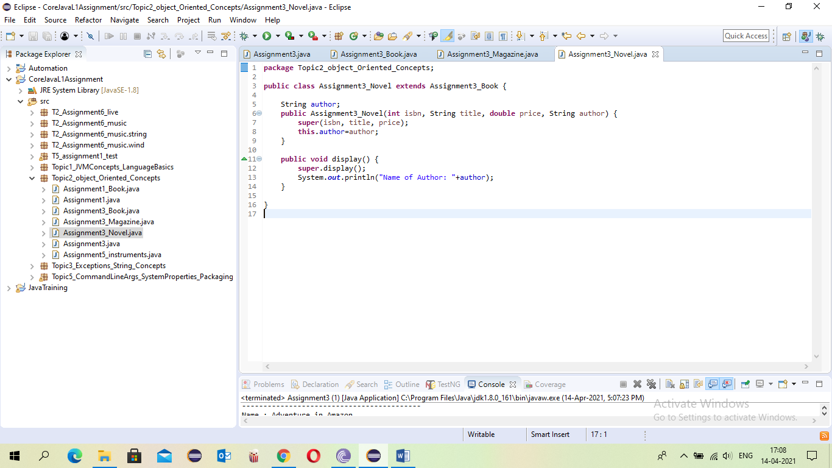

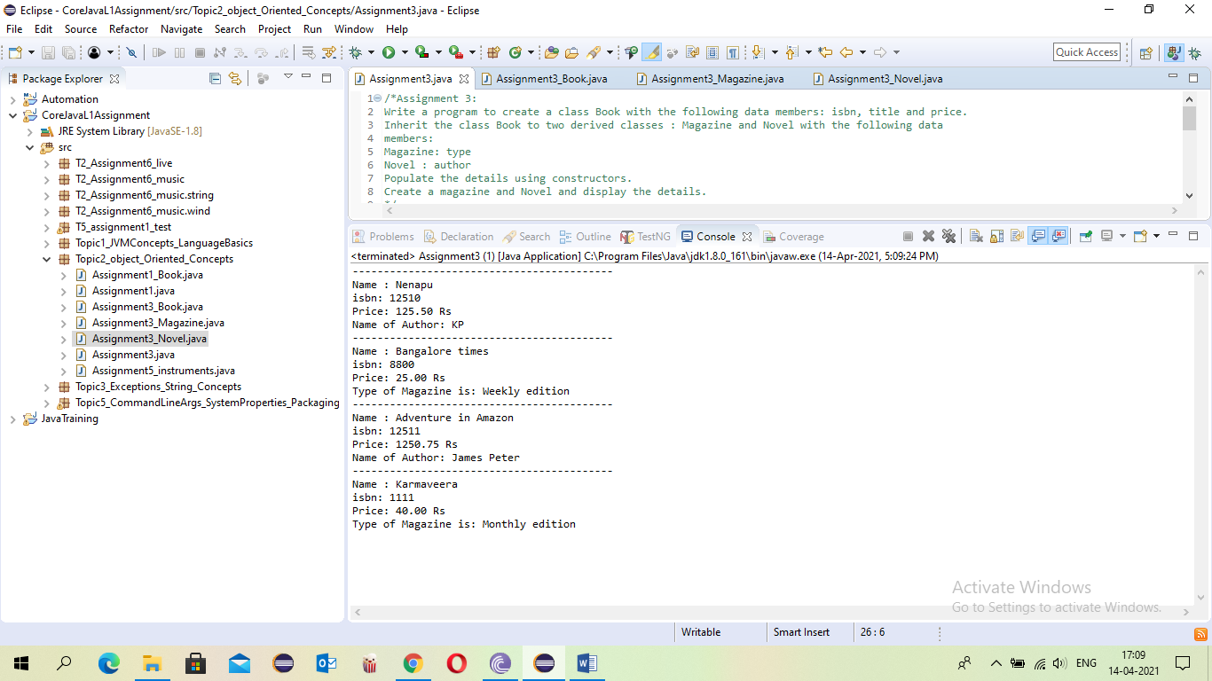

* Assignment 5: Create an abstract class Instrument which is having the abstract function play. Create three more sub classes from Instrument which is Piano, Flute, Guitar. Override the play method inside all three classes printing a message “Piano is playing tan tan tan tan ” for Piano class “Flute is playing toot toot toot toot” for Flute class “Guitar is playing tin tin tin ” for Guitar class You must not allow the user to declare an object of Instrument class. Create an array of 10 Instruments. Assign different type of instrument to Instrument reference. Check for the polymorphic behavior of play method. Use the instanceof operator to print that which object stored at which index of instrument array.

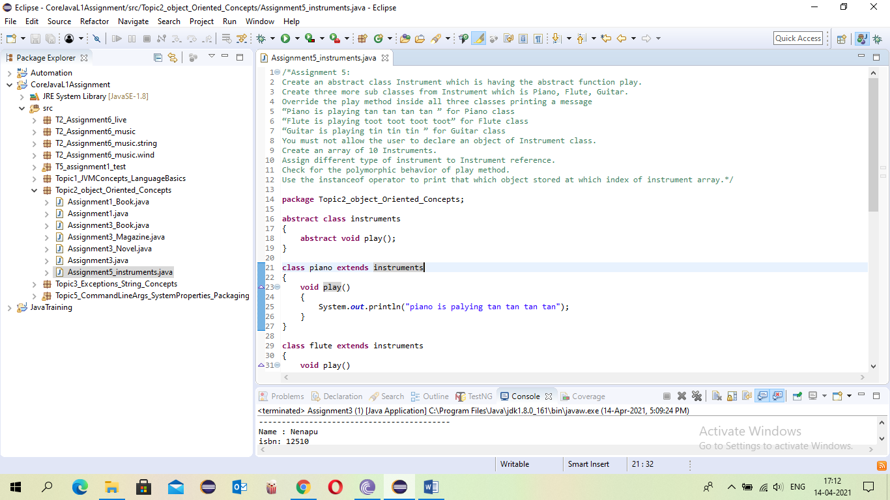

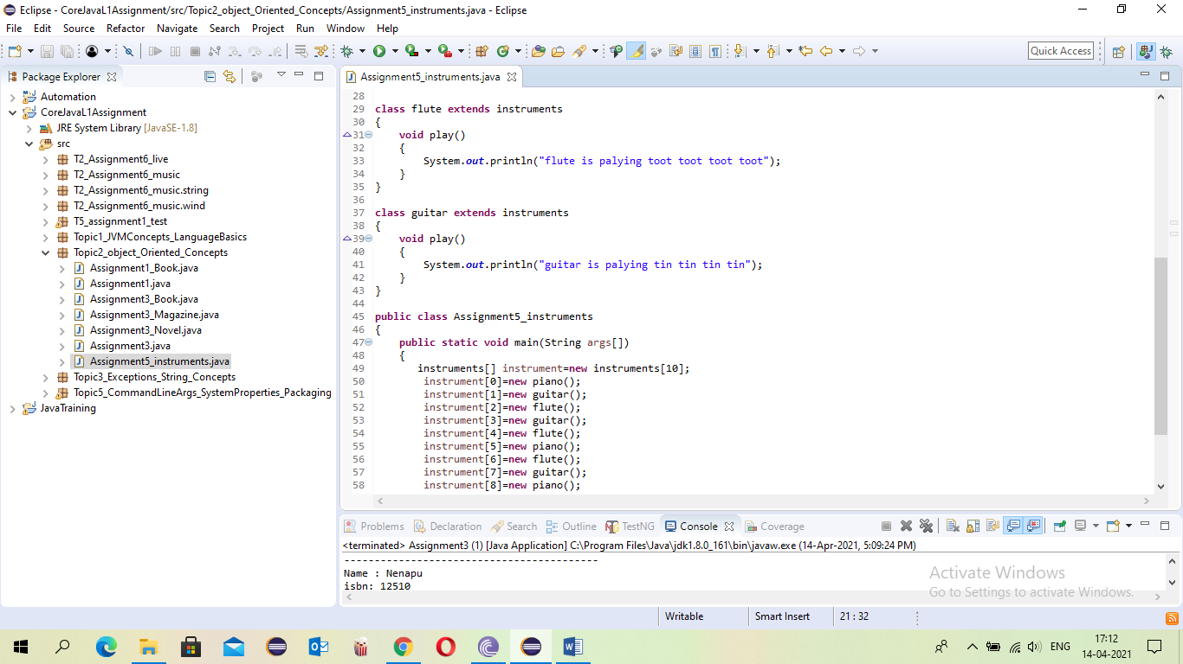

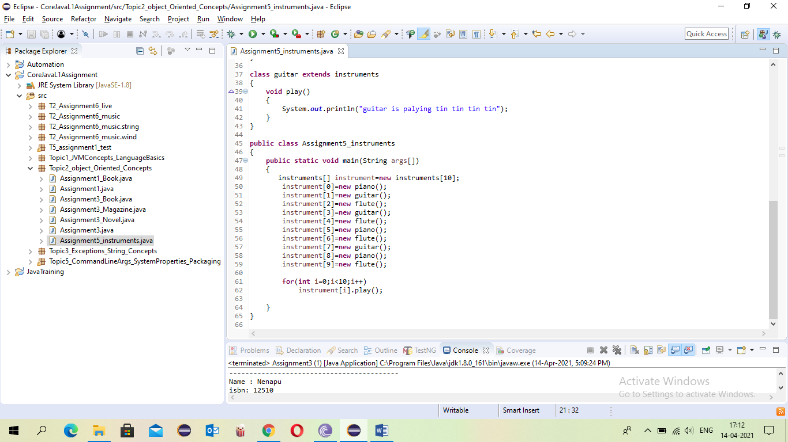

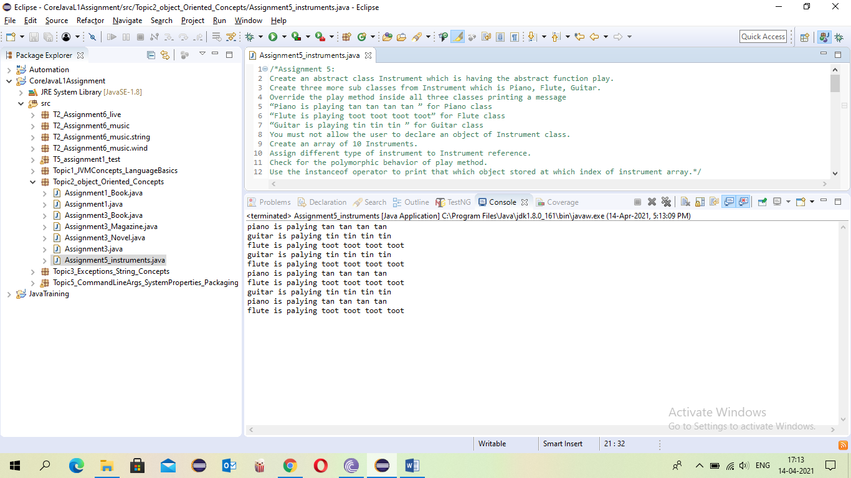

* Assignment 6: Write an interface called Playable, with a method void play(); Let this interface be placed in a package called music. Write a class called Veena which implements Playable interface. Let this class be placed in a package music.string Write a class called Saxophone which implements Playable interface. Let this class be placed in a package music.wind Sensitivity: Internal & Restricted Write another class Test in a package called live. Then, a. Create an instance of Veena and call play() method b. Create an instance of Saxophone and call play() method c. Place the above instances in a variable of type Playable and then call play()

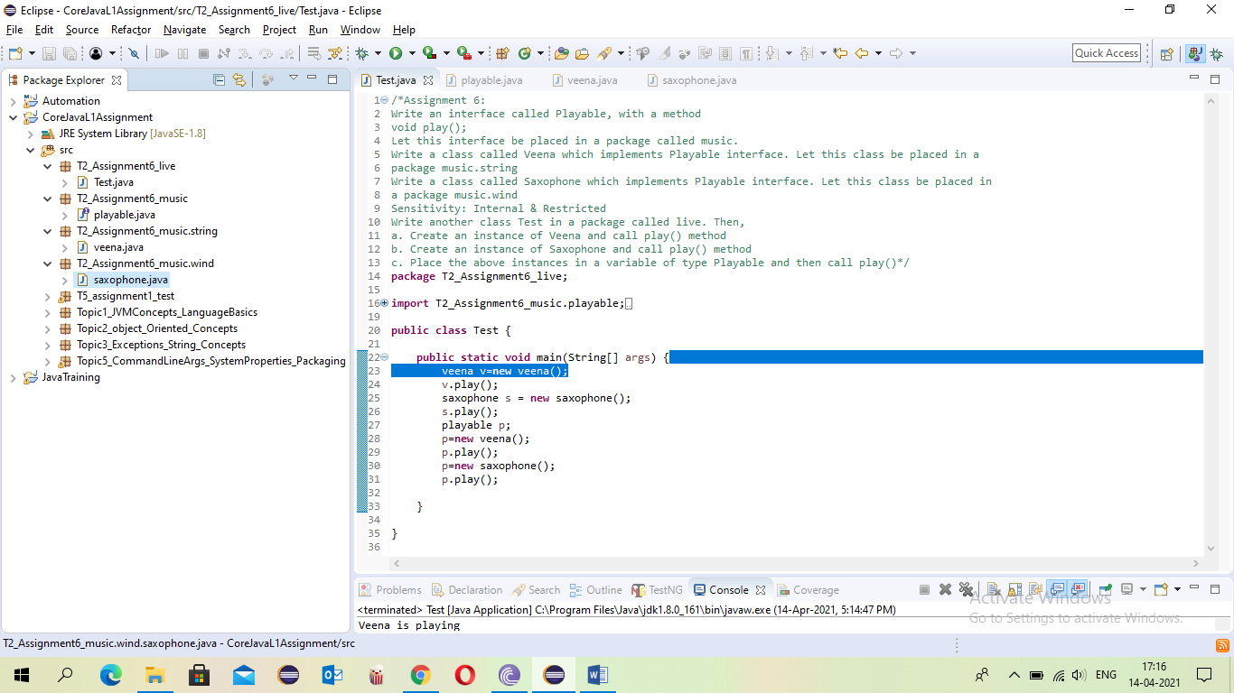

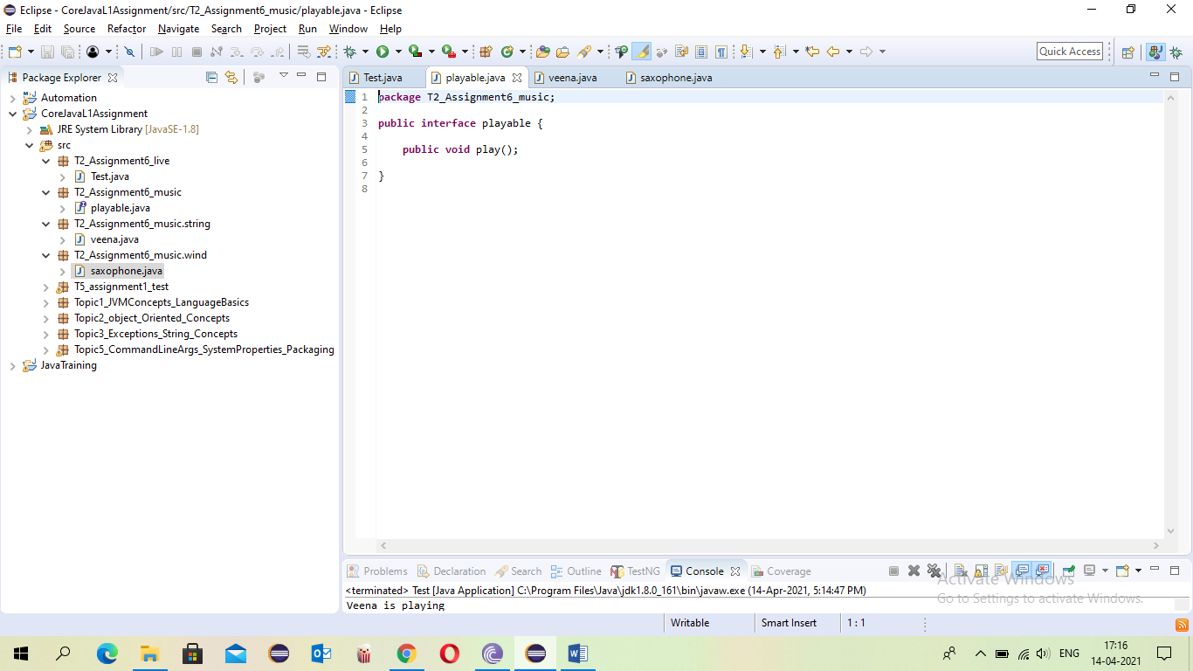

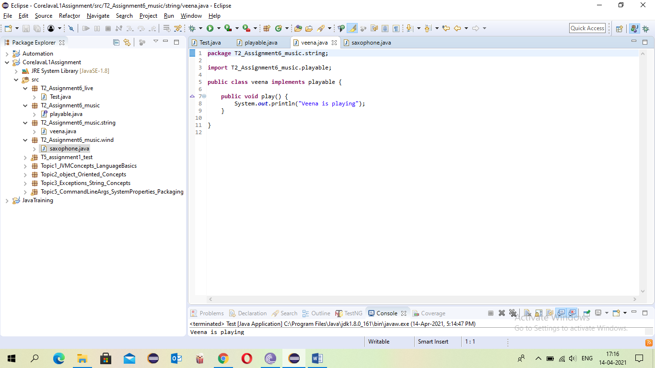

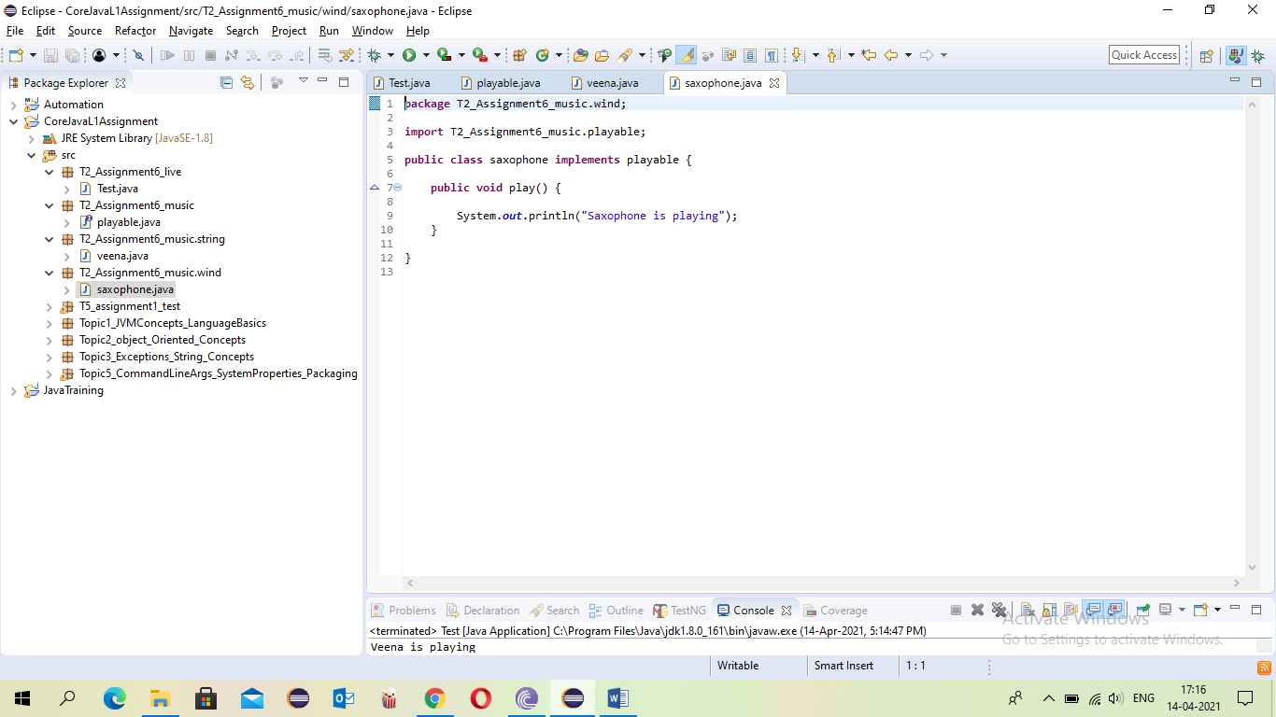

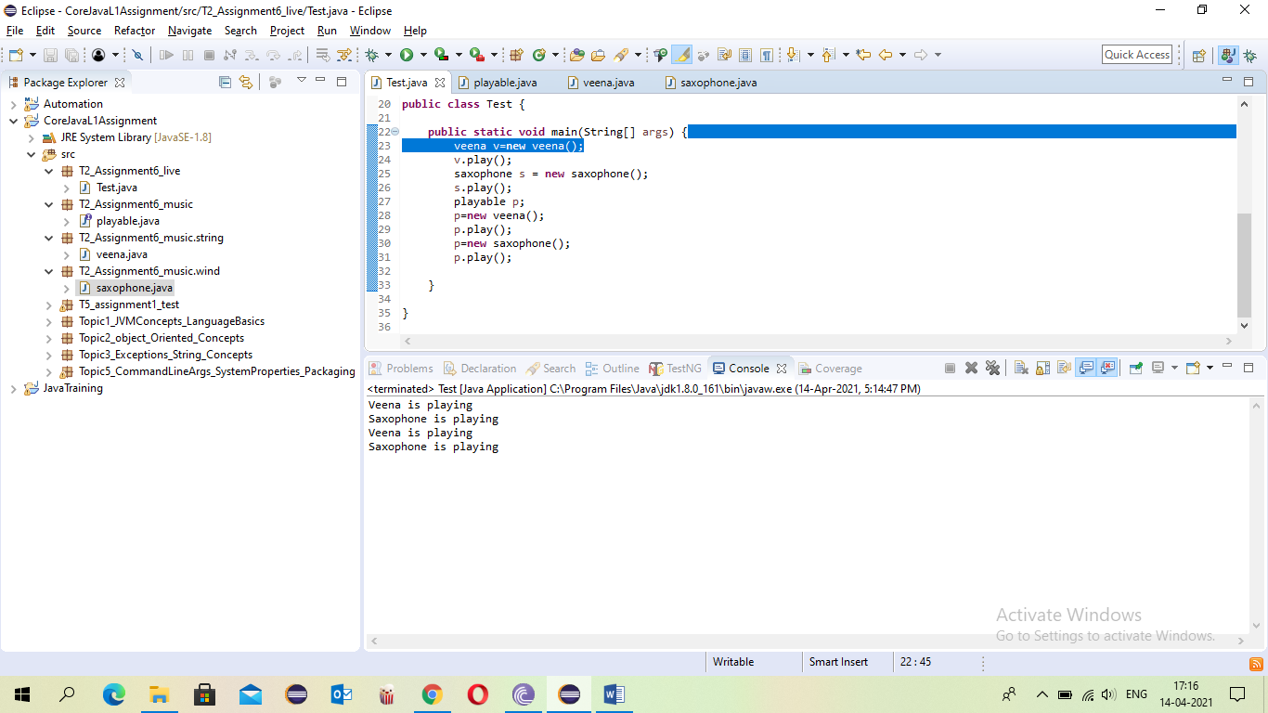

1. Topic 3: Exceptions, String Concepts(4 questions)

* Assignment 1: Write a program to accept name and age of a person from the command prompt(passed as arguments when you execute the class) and ensure that the age entered is >=18 and < 60. Display proper error messages. The program must exit gracefully after displaying the error message in case the arguments passed are not proper. (Hint : Create a user defined exception class for handling errors.)

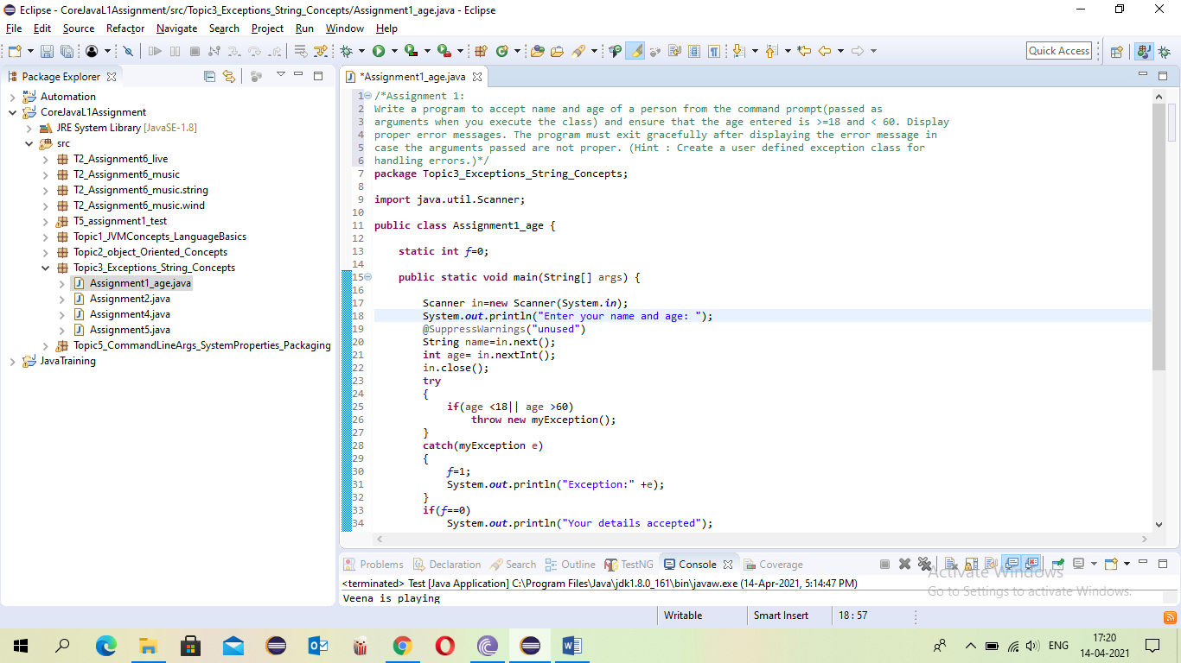

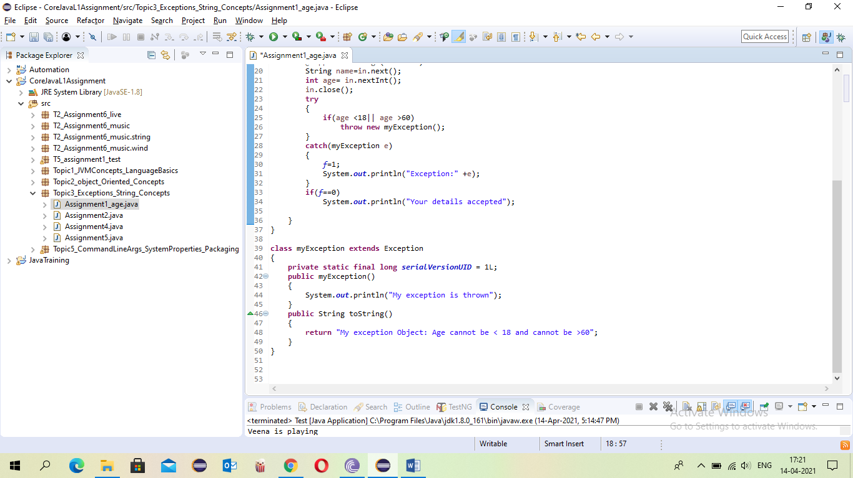

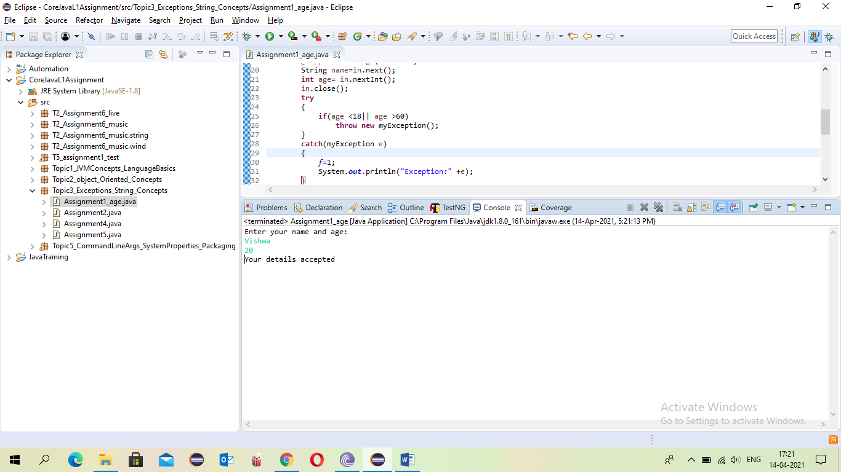

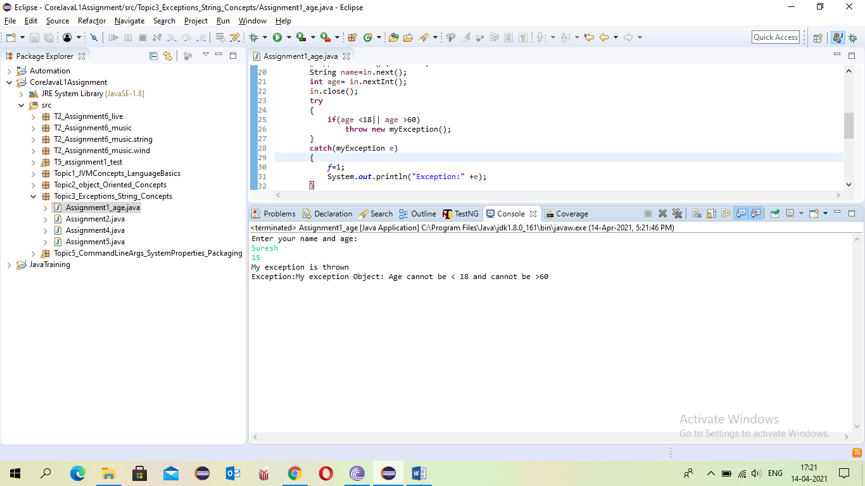

* Assignment 2: Write a Program to take care of Number Format Exception if user enters values other that integer for calculating average marks of 2 students. The name of the students and marks in 3 subjects are passed as arguments while executing the program.

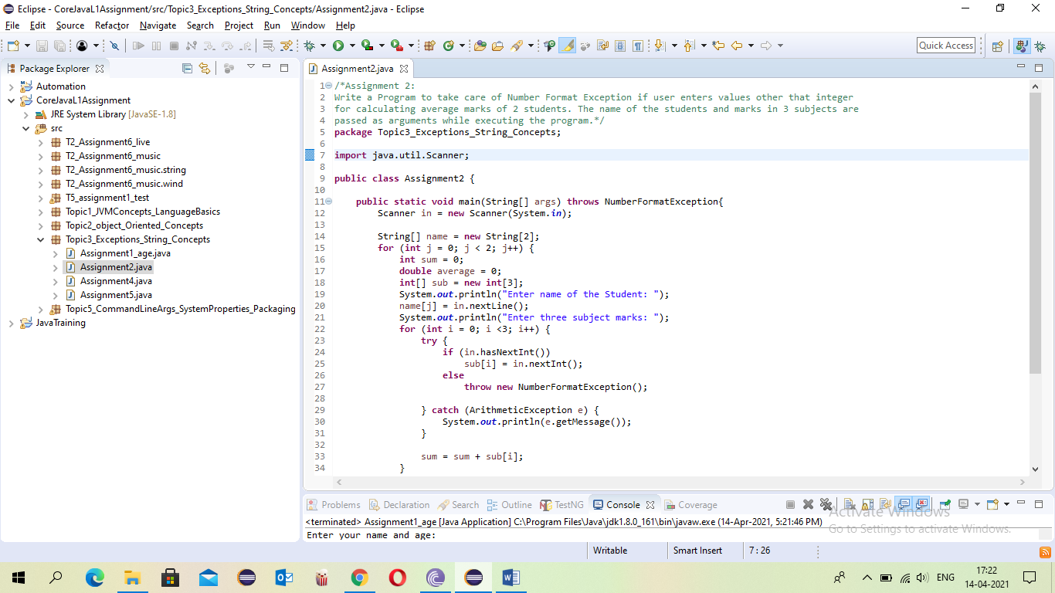

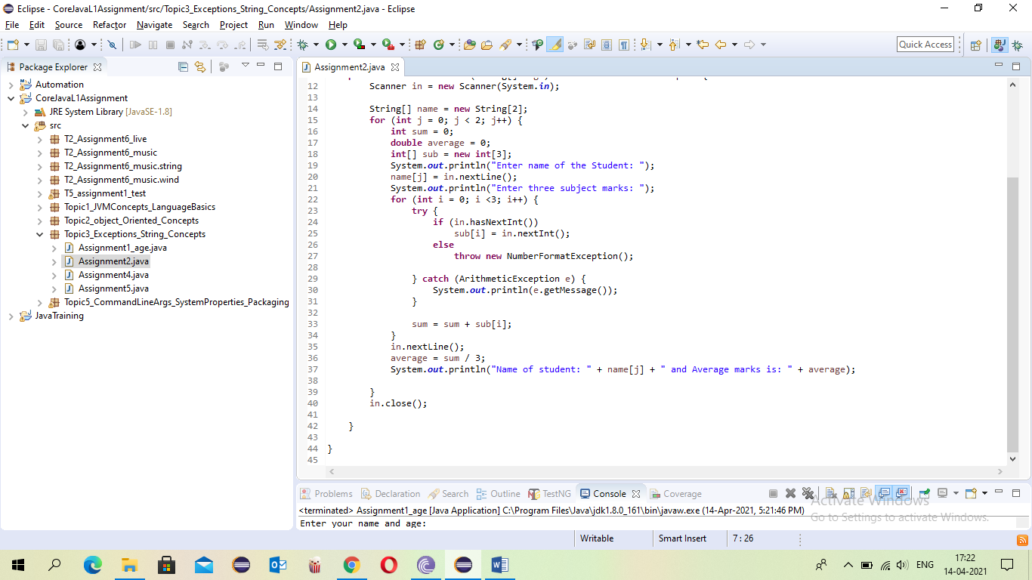

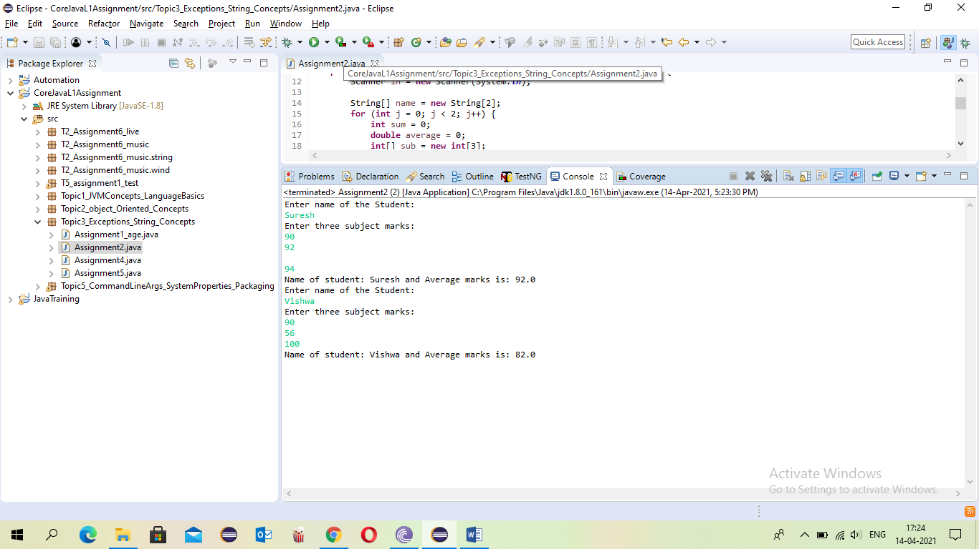

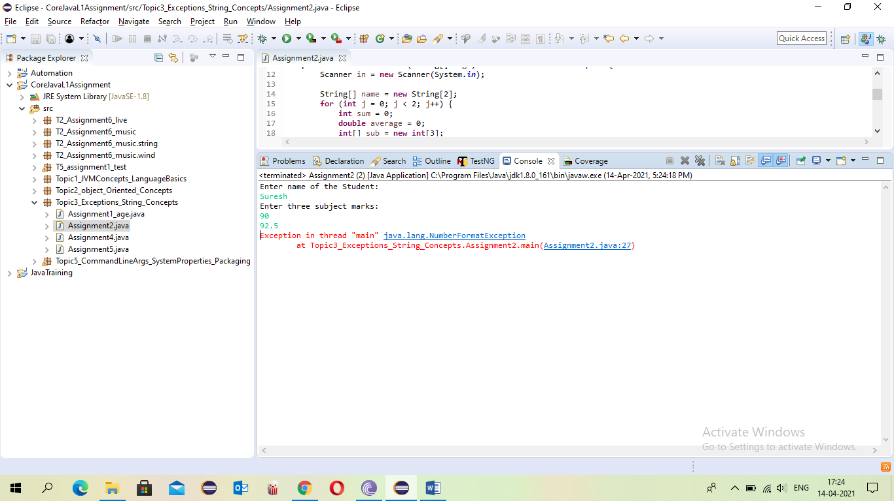

* Assignment 4: Write a program to check whether the given string is a palindrome or not. [Hint :You have to extract each character from the beginning and end of the String and compare it with each other. String x=”Malayalam”; char c= x.charAt(i) where i is the index]

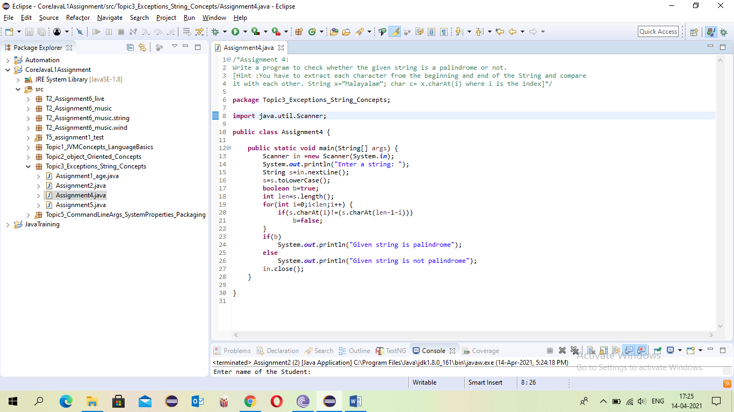

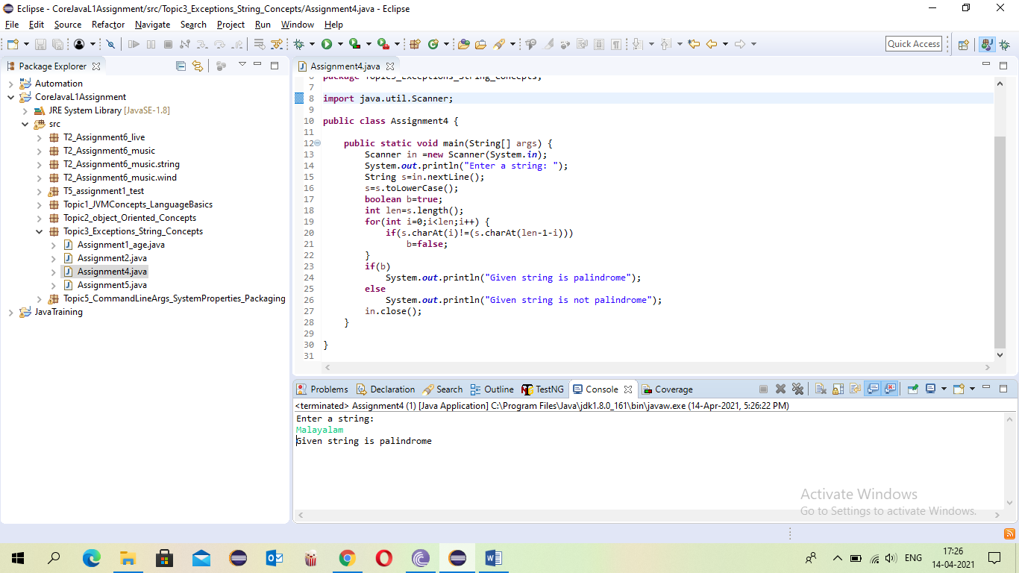

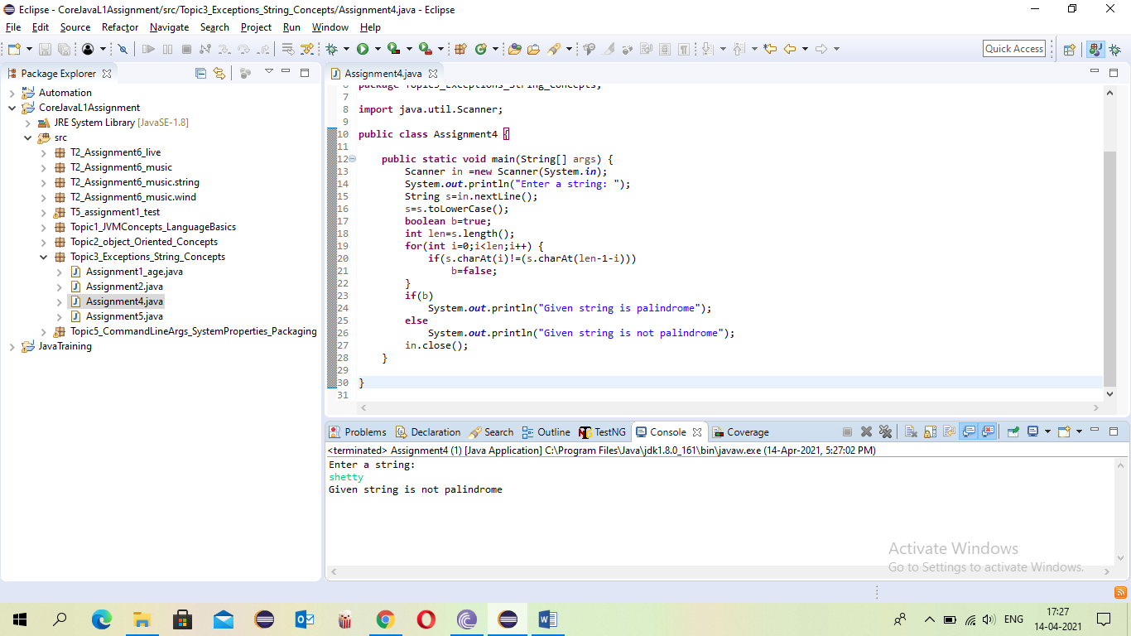

* Assignment 5: Write a program to check the no.of occurrences of a given character within the given string without using any loop. [Hint: String str=”How was your day today”; char c=’a’; no.of occurrences of a is=3]

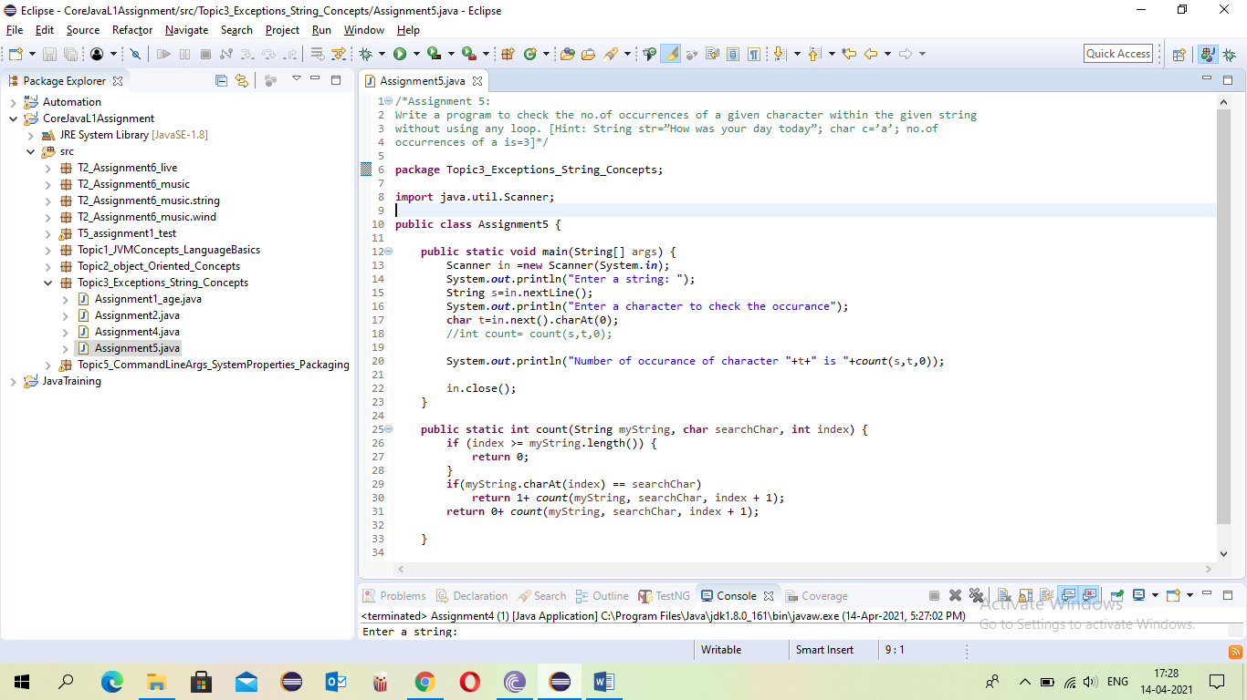

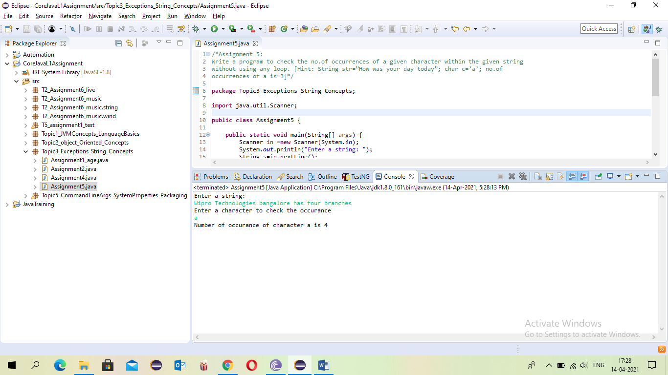

1. Topic 4: Threads, Collection Framework, Garbage Collection(5 Questions)

* Assignment 1: Write a Java Program, where one thread prints a number ( Generate a random number using Math.random) and another thread prints the factorial of that given number. Both the outputs should alternate each other. Eg: Number : 2 Factorial of 2 : 2 Number : 5 Factorial of 5 : 120 The program can quit after executing 5 times.

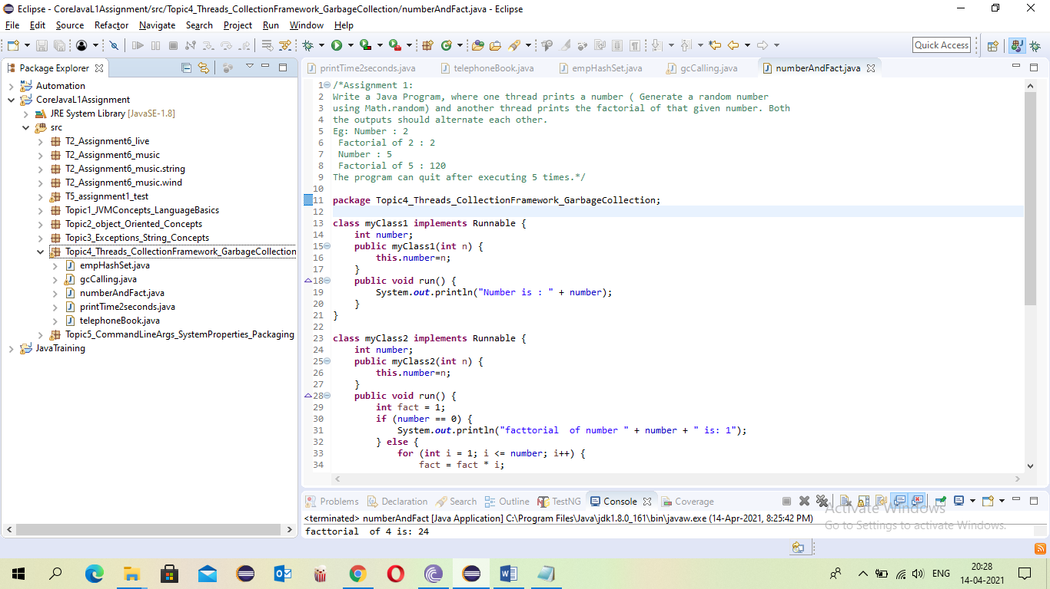

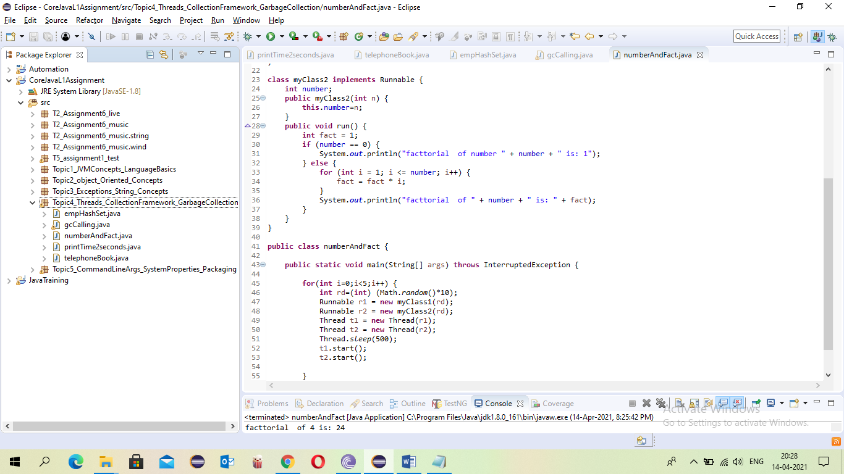

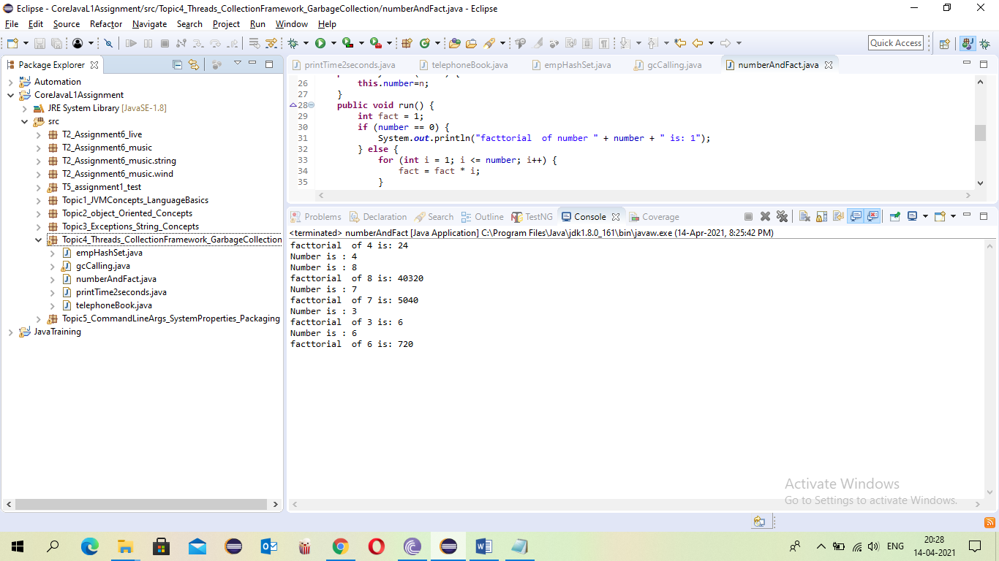

* Assignment 2: Write a Java Program which will print the current time on the console every 2 seconds. After doing this activity for 20 seconds the program quits.

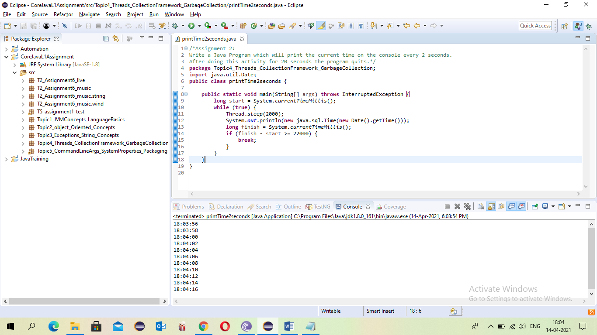

* Assignment 4: Write a program creates a HashMap to store name and phone number (Telephone book). When name is give, we can get back the corresponding phone number.

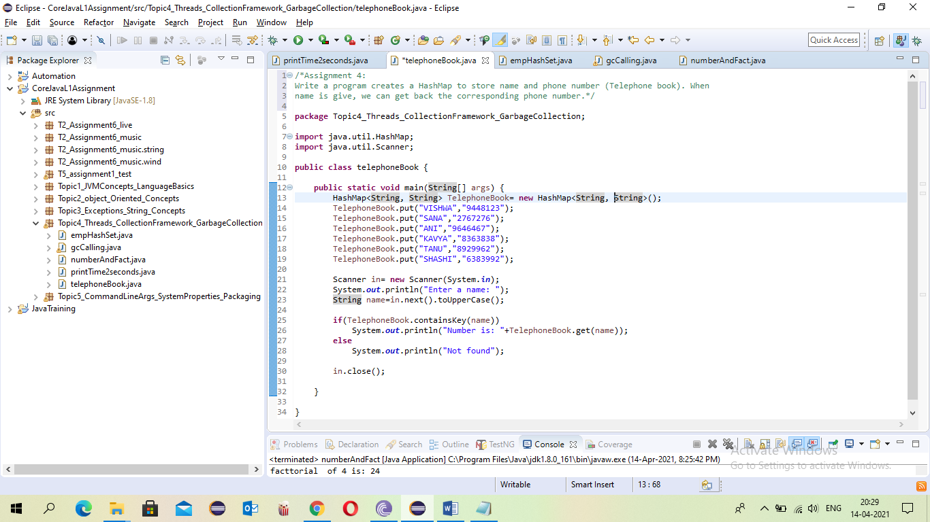

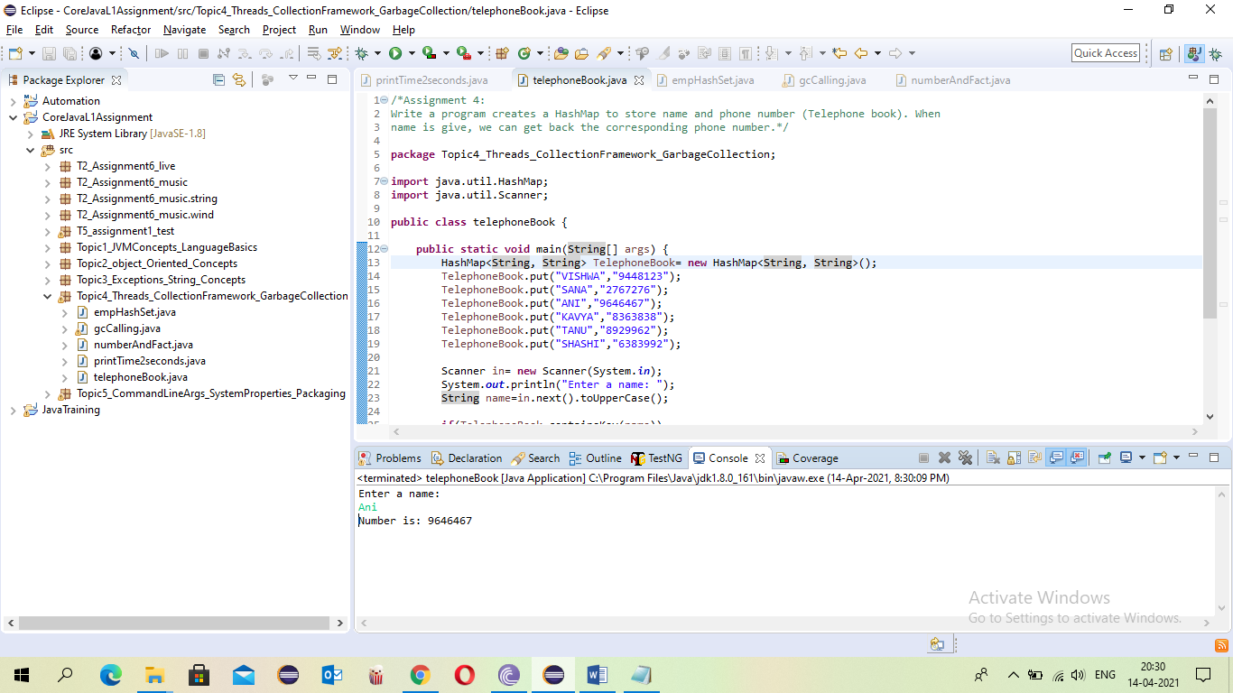

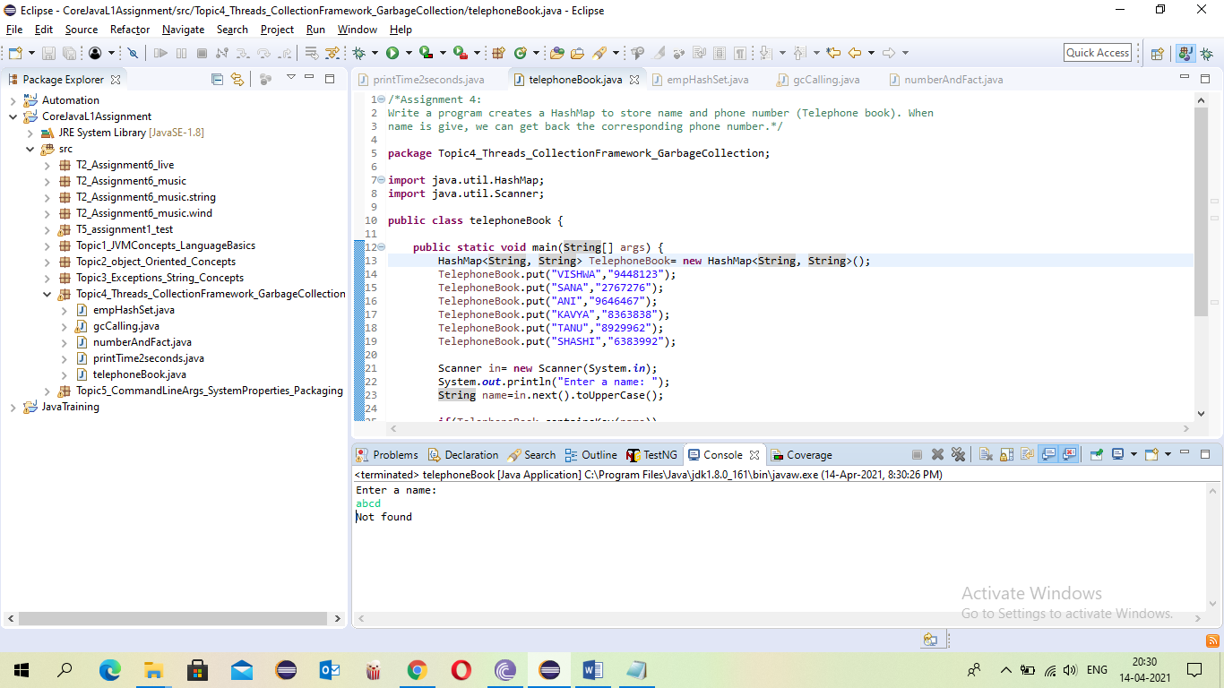

* Assignment 5: Write a program to store a group of employee names into a HashSet, retrieve the elements one by one using an Iterator.

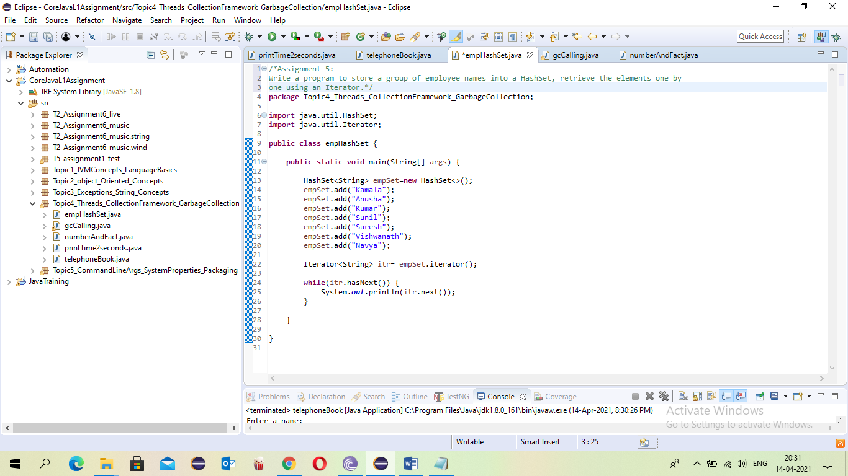

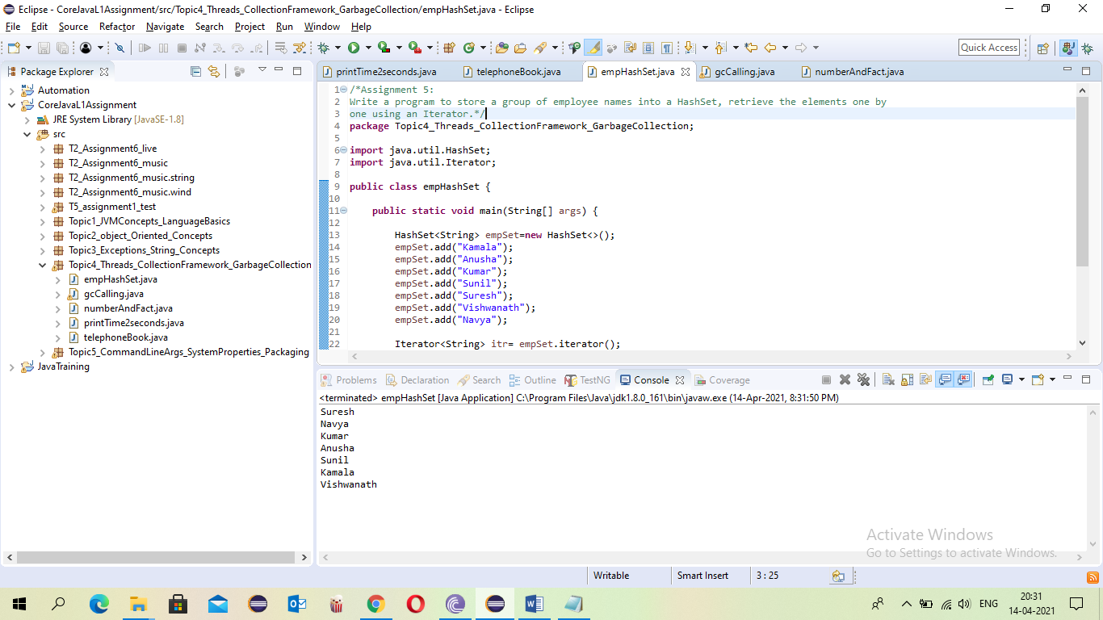

* Assignment 6: Develop a java class that has finalize method which displays “Finalize method called”. Create another class which creates objects of the previous class and it uses the same object reference for creating these objects. For example, if A1 is the class name, then the objects are created as Sensitivity: Internal & Restricted below : A1 a = new A1(); a = new A1(); a = new A1(); When the statement Runtime.getRuntime().gc() is invoked, how many times the finalize method is called

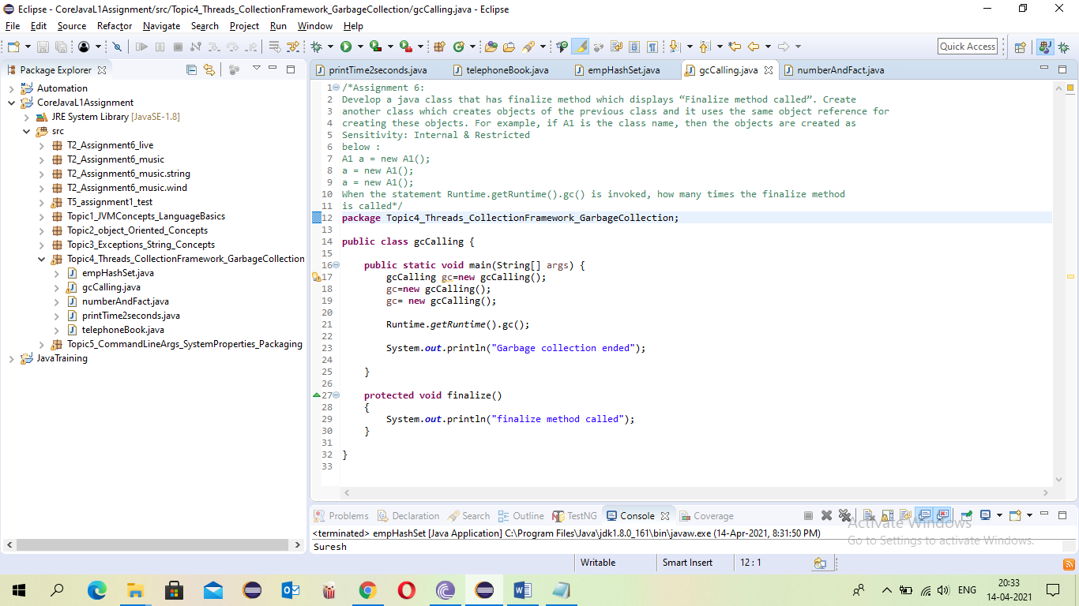

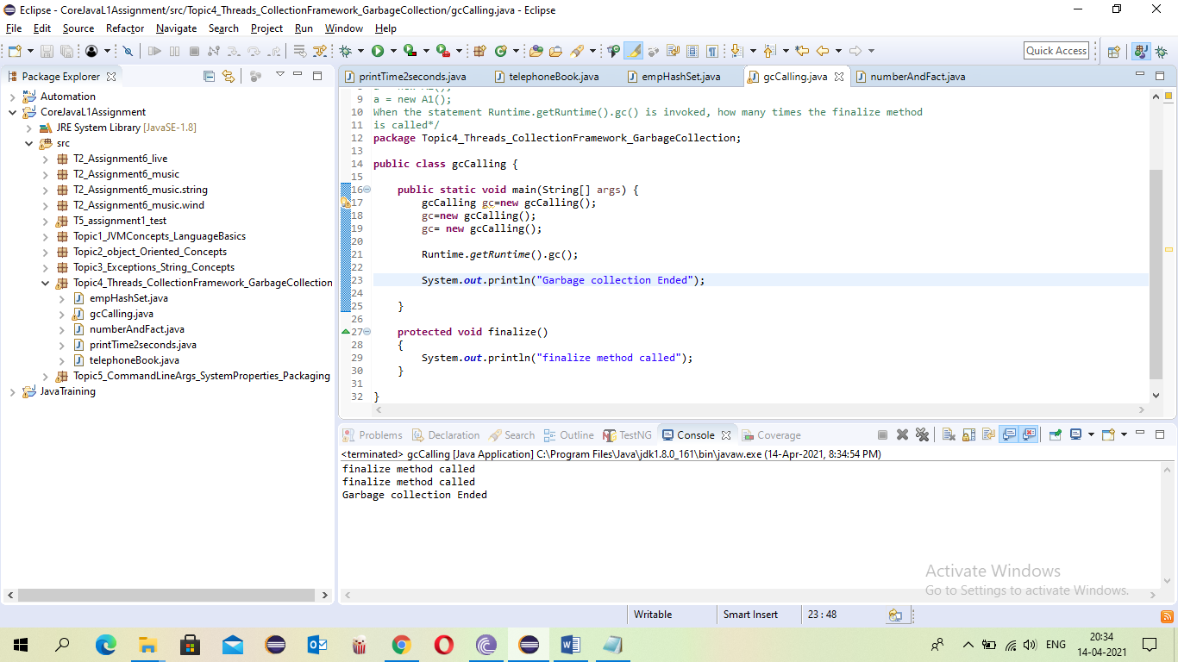

1. Topic 5: Command Line Args, System Properties, Packaging( 2 Questions)

* Assignment 1: Create a package called test package; Define a class called foundation inside the test package; Inside the class, you need to define 4 integer variables; Var1 as private; Var2 as default; Var3 as protected; Var4 as public; Import this class and packages in another class. Try to access all 4 variables of the foundation class and see what variables are accessible and what are not accessible.

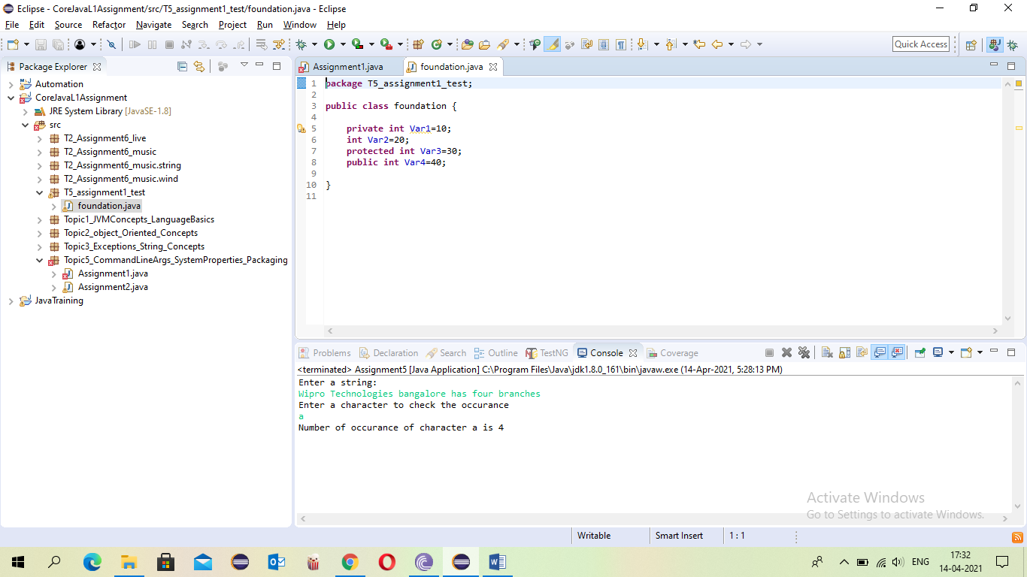

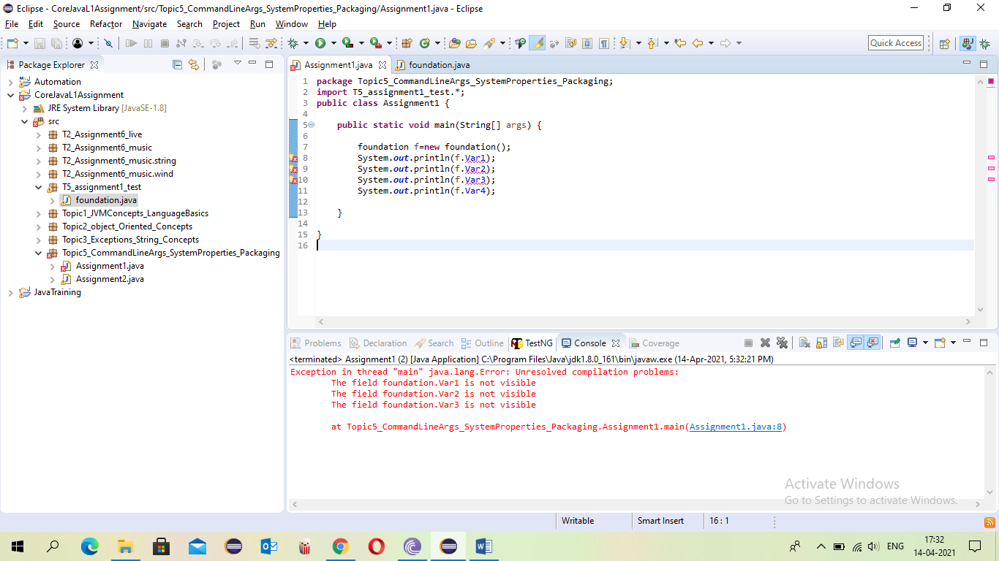

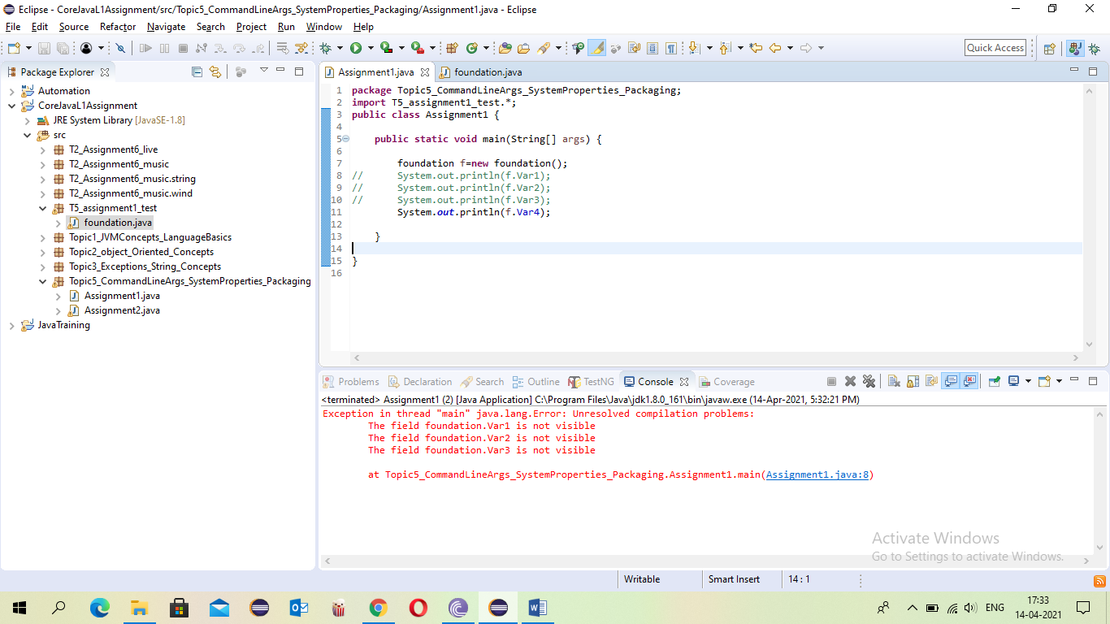

* Assignment 2: Write a Program to accept two Strings Wipro Bangalore as command line arguments and print the output “Wipro Technologies Bangalore” If the command line is “ABC Mumbai”, then it should print “ABC Technologies Mumbai” .

